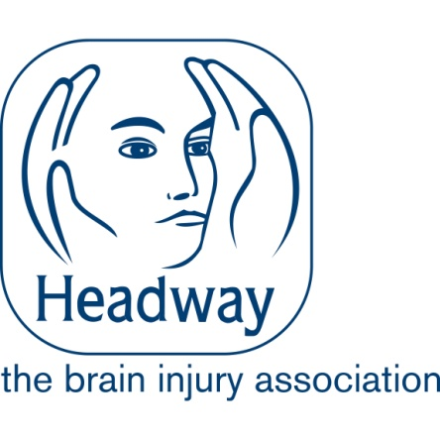

**Role Profile**

**Individual Giving Fundraiser**

|  |  |
| --- | --- |
| **Team:** | Fundraising Team |
| **Reporting to:** | Director of Fundraising |
| **Responsible for:** | NA |
| **Grade:** | £28,000 per annum |
| **Location**  **Fixed Term:** | Either home based or in the Headway office in Nottingham, or hybrid between the two.  (Maternity cover) Until November 2026 |

|  |
| --- |
| **The role purpose**  As the Individual Giving Fundraiser, you will be responsible for overseeing and managing Headway UK’s portfolio of individual donations. This includes contributions from Friends of Headway members, regular and payroll givers, and in-memory donors. Your role will be pivotal in achieving key objectives and supporting the charity to meet its income targets. |

|  |
| --- |
| **Overview of the Department/Team**  The Fundraising Department is responsible for generating £5.8 million in income to support the charity’s services, £4 million through Retail and £1.8 million through Fundraising.  We achieve this through our network of 28 charity shops, managed by the Retail team, and by raising funds across Events, Community Fundraising, Corporate Partnerships, Individual Giving and Trusts & Foundations.  Reporting to the Director of Fundraising, the Individual Giving Fundraiser will lead the development, planning, and execution of strategies to acquire and retain individual donors. This includes managing donor journeys to ensure effective stewardship, maximise income, and increase lifetime value. |
|  |

|  |
| --- |
| **Key areas of accountability** |
| **Planning and Delivery**   * To work with the Marketing Manager to deliver two new appeals and campaigns across channels to engage new and existing supporters. * Implement a stewardship programme to increase long-term support from donors. * Collaborate with the teams across the organisation to raise the charity's profile. * Be creative in developing materials to strengthen individual giving. * Expand in-memoriam donations through partnerships and relationships. * Work with the Director of Fundraising to manage the Gifts in Wills, legacy platform and potential legacy givers.   **Donor Engagement and Stewardship**   * Use the charity (CRM) database to maintain accurate records, conduct data segmentation, and generate income and KPI reports to ensure effective management of all individual giving activities. * Test and trial new acquisition and retention channels based on audience insight and sector trends. * Enhance opportunities for Gift Aid. * Increase donor lifetime value, through effective stewardship.   Be an active member of the Fundraising team, supporting with wider income generation, events and Headway’s profile. |

|  |
| --- |
| **Corporate responsibilities** |
| * **Safeguarding** –Safeguarding is at the heart of what we do and every member of staff has a duty ensure that they understand and follow safeguarding procedures to promote the welfare of our staff and service users. * **H&S** –We are an employer who is committed to Health and Safety and you will have a role to play ensuring that we continue to embed a health and safety culture. * **GDPR** – You will help ensure that we remain fully compliant of our obligations in respect of data. * **Equal Opportunities** is a key value of Headway UK. Every member of staff has a personal responsibility to ensure that they behave in an inclusive way and contribute to our diversity goals. * **You are an Ambassador for Headway UK** – We want all our staff, regardless of roles to be our Ambassadors, representing the charity and promoting the work we do. * **Fundraising Code Compliance** – You will be responsible for ensuring your fundraising practice aligns with the Code of Fundraising Practice. This includes upholding ethical standards, transparency, and accountability in all fundraising activities. |

**Person Specification**

**Individual Giving Fundraiser**

|  |  |  |
| --- | --- | --- |
| **Qualifications** | **Essential/ Desirable** | **Assessment Method**  **Application/ Interview** |
| **Experience and Knowledge** |  |  |
| * Have experience of income generation, through individual giving fundraising. | Essential | Interview and application |
| * Experience of Donor acquisition and stewardship | Desirable | Interview |
| * Proficiency in working with databases and CRM platforms (e.g. Salesforce) | Essential | Application |
| * Experience in project management, including scheduling, data management, briefing documents, budget management, and results analysis and reporting. | Essential | Interview and application |
| **Skills and Abilities** |  |  |
| * Experience using insights to inform decision-making. | Desirable | Interview |
| * The ability to work independently, seek support when needed, and collaborate effectively as part of a team. | Essential | Interview and application |
| * High computer literacy, particularly with Microsoft Office applications such as Word, Excel, and Outlook. | Essential | Application |
| **Other** |  |  |
| Demonstrate a clear understanding of safeguarding (adults at risk) | Essential | Interview |
| Demonstrate a clear understanding of equality of opportunity and diversity issues | Essential | Application |
| Demonstrate a clear understanding of GDPR and the impact that it has on the role day to day. | Essential | Application |
| Demonstrate a clear understanding of health and safety. | Essential | Application |
| Appropriate workstation and set up to facilitate you working from home e.g. desk, adjustable chair etc | Essential | Interview |

Please note this role is subject to a Basic criminal records check.