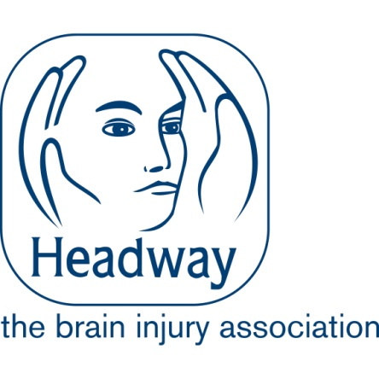
Role Profile
Events Fundraising Manager
Team: | Fundraising Team
Reporting to: | Director of Fundraising
Responsible for: | Fundraising Coordinator – Events
Grade: | £38,000
Location | Hybrid, with a minimum of one day, per week, in the Nottingham Office

The role purpose
The Events Fundraising Manager plays a pivotal part in increasing Headway’s national visibility and fundraising impact, directly supporting our mission to improve life after brain injury. You will take ownership of developing a forward-thinking events strategy, strengthening supporter engagement, and driving sustainable income growth.

In addition to this strategic leadership, the Events Fundraising Manager will drive participation and maximise income by planning, delivering, and developing the charity’s events programme, including virtual challenges, an annual Golf Day, and Headway’s Annual Awards.

To raise income via third party events, including the London Marathon, the Great North Run and London Landmarks.

Overview of the Department/Team

The Fundraising Department is responsible for generating £5.8m of income to support the charities services. £4m Retail and Fundraising £1.8m. We do this through our Retail team and 28 Charity Shops and raising funds across Events, Community Fundraising, Corporate Partners, Individual Giving, Legacies and Trust and Foundations.

The Events Fundraising Manager along with the Fundraising Coordinator (Events), is responsible for raising approximately £360,000 in income.

Reporting to the Director of Fundraising, you will be responsible for delivering our existing portfolio of events, stewarding participants through third party events and scoping out options for extending the events calendar to raise more income and visibility of Headway. This includes stewarding participants through an appropriate supporter journey to maximise income and lifetime value.

Key areas of accountability
Planning and Delivery
- Plan, organise, and deliver Headway’s events programme.
- Manage all aspects of event planning, including budget, health and safety, and delivery.
- Collaborate with third-party event organisers to negotiate contracts and ensure value for money.
- Work with the Communications Team to enhance event marketing and communications.
- Line manage the Fundraising Coordinator (Events), providing guidance and support to achieve team objectives.
- Innovate and test new fundraising opportunities to expand the event portfolio.

Stewardship
- Develop and implement stewardship plans to ensure a high-quality supporter journey.
- Maintain accurate supporter records in the CRM system for effective engagement and compliance with GDPR.
- Monitor and report on financial performance and supporter metrics.
- Develop strong relationships with event participants to encourage ongoing support.

Success in this role will be demonstrated through increased participation, improved supporter retention, and year-on-year growth in events income.

Corporate responsibilities
- Safeguarding –Safeguarding is at the heart of what we do and every member of staff has a duty ensure that they understand and follow safeguarding procedures to promote the welfare of our staff and service users.
- H&S –We are an employer who is committed to Health and Safety and you will have a role to play ensuring that we continue to embed a health and safety culture.
- GDPR – You will help ensure that we remain fully compliant of our obligations in respect of data.
- Equal Opportunities is a key value of Headway UK. Every member of staff has a personal responsibility to ensure that they behave in an inclusive way and contribute to our diversity goals.
- You are an Ambassador for Headway UK – We want all our staff, regardless of roles to be our Ambassadors, representing the charity and promoting the work we do.

Person Specification
Events Fundraising Manager
Criteria | Essential/ Desirable | Assessment Method  Application/ Interview
Qualifications
Relevant professional experience in event management, fundraising, marketing, or a related field. | Essential | Application
A professional qualification or training in event management, fundraising, or marketing (e.g., CIM, IoF, or equivalent) | Desirable | Application
Experience and Knowledge

Proven experience in planning, organising, and delivering a diverse range of events, including challenge events, networking conferences, and high-profile dinners | Essential | Interview
Experience in budget management, health and safety compliance, and post-event evaluation. | Essential | Interview
Experience negotiating contracts and managing relationships with third-party event organisers, suppliers, and venues. | Desirable | Interview
Strong understanding of fundraising principles, supporter engagement strategies, and event marketing | Essential | Interview
Experience in using Customer Relationship Management (CRM) systems | Desirable | Application
Knowledge of event regulations, legal responsibilities, and sector best practices | Essential | Application
Skills and Abilities

Exceptional organisational skills, with the ability to manage multiple projects simultaneously and meet deadlines. | Essential | Interview
Strong interpersonal and relationship-building skills, with the ability to engage and collaborate with diverse stakeholders, including participants, volunteers, and third-party organisers. | Essential | Interview
Excellent written and verbal communication skills, including the ability to craft compelling marketing materials and reports. | Essential | Application
Proficiency in digital tools for event promotion and delivery (e.g., online fundraising platforms, email marketing systems, social media promotion). | Essential | Interview
Analytical skills to monitor financial performance and evaluate event success against Key Performance Indicators. | Essential | Interview
Creative problem-solving and innovation to identify and test new fundraising opportunities | Essential | Interview
Attention to detail and accuracy in record-keeping and reporting. | Essential | Application
Other

Ability to lead, support, and develop junior team members, such as the Fundraising Coordinator (Events), fostering a positive and high-performing team culture. | Essential | Interview
Ability to work flexibly, including occasional evenings and weekends as required by the events programme. | Essential | Interview
A valid driver’s license and access to transport (necessary for event delivery). | Essential | Application
Familiarity with the challenges faced by people with acquired brain injuries and their carers | Desirable | Interview
Demonstrate a clear understanding of safeguarding (adults at risk) | Essential | Interview
Demonstrate a clear understanding of equality of opportunity and diversity issues | Essential | Interview
Demonstrate a clear understanding of GDPR and the impact that it has on the role day to day. | Essential | Interview
Demonstrate a clear understanding of health and safety. | Essential | Interview
Appropriate workstation and set up to facilitate you working from home e.g. desk, adjustable chair etc | Essential | Interview

Please note this role is subject to a basic criminal records check.

