**Communities and Local Government Committee**

Inquiry into the financial stability of local authority adult social care

Submission from Headway – the brain injury association (Headway UK)

Headway UK is a national umbrella charity (no. 1025852) that supports people affected by brain injury. Through direct services and a network of more than 125 groups and branches across the UK, it provides support, services and information to brain injury survivors, their families and carers, as well as to professionals in the health and legal fields.

**Brain injury is life changing and can challenge every aspect of your life – walking, talking, thinking and feeling – and the losses can be severe and permanent. It can mean losing both the life you once lived and the person you once were. But with the right help, at the right time, there can be life after brain injury.**

For more than 35 years, Headway UK has been providing that help. Each year, the charity helps thousands of people to manage and adapt to life after brain injury, where possible learning new skills, relearning lost skills, regaining a degree of independence and therefore reducing long-term state dependence for support and care needs.

Many of the local Headway groups (which are autonomous charities affiliated to the UK-wide organisation), rely on local authority funding in order to deliver their crucial services. There is no doubting the value for money these services offer, particularly when examined against the alternatives that may include long-term residential care or out-of-area rehabilitation at a significant cost to local authority budgets.

However, in a study conducted by Headway UK, the vast majority of these relatively small, local Headway groups are under increasing financial strain as a result of reduced funding from their local authorities.

The study found that:

* 83.3% were concerned about their organisation’s ability to provide support services in the long-term if local authority/NHS funding cuts continue.
* 89.3% reported having to subsidise services, events or outings as a result of funding cuts. This means using charitable reserves in order to maintain vital services or having to use funds intended for other purposes.
* Over half (56.9%) reported that changes to local authority support had a negative impact on their ability to provide essential support services.
* 23.6% reported a decrease in the number of service users accessing their services as a direct result of changes in local authority funding.
* Almost one-third (30.6%) have had to cut services or activities as a result of reduced local authority/NHS funding.

It is also important to note that this study was conducted in 2014. Anecdotal evidence since then would suggest that the continuing austerity measures and financial pressure on local authorities is having a greater impact on Headway groups more today than two years ago.

The report also asked Headway group representatives to provide written evidence. Submissions included:

* *“Local authorities have increased their criteria for funding to ‘substantial or critical’ to agree to spot-fund our service. They are also now more reluctant to fund outside their area even if they don't have a service which meets the needs of the client.”*
* *“We are expected to provide a very high level of support with a minimum of funding. The paperwork has doubled and we have to "jump through hoops". Staff are very thin on the ground and are stretched to capacity; if we can't afford to employ more staff then we are not going to develop our services.”*
* *“As funding continues to be cut, with an increasing number of people requiring our support, this will reduce our ability to support those affected by brain injury. A very gloomy forecast.”*
* *“We have had to reduce the number of days we are open, reduce activities on offer, cut out activities requiring extra resources, cut outings, reduce the number of paid staff (impacting on the range of activities on offer), and increase our reliance on volunteers to support activities. We have concerns about the quality implications of the above, with year-on-year uncertainty for clients that the service will be sustained. Projects which were developing between 2008-2011 have ceased.”*

The findings paint a gloomy picture, not least because of the implications for the future. While the local Headway groups are under increasing financial pressure to cut or stop services, the number of people requiring support following brain injury continues to rise.

A further concern expressed was cutting budgets for transport, to allow people to attend Headway groups. It makes no sense for a local authority to pay for somebody to attend the service, yet withdraw transport funding for those people who are unable to attend or have to find funds, more often than not, from their benefit payments, which may also be under review and threat.

In addition, Headway UK has seen a 30% reduction in the number of training courses provided to local authorities on key subjects such as Understanding Brain Injury. This reduces knowledge and understanding of the key issues for local authority staff supporting people with brain injury, their families and carers.

This creates a vicious circle as resources become more and more stretched. There is grave concern among groups and branches, both for current service users and the many thousands of survivors of a brain injury that they may never have the opportunity to help.

**Increasing demand**

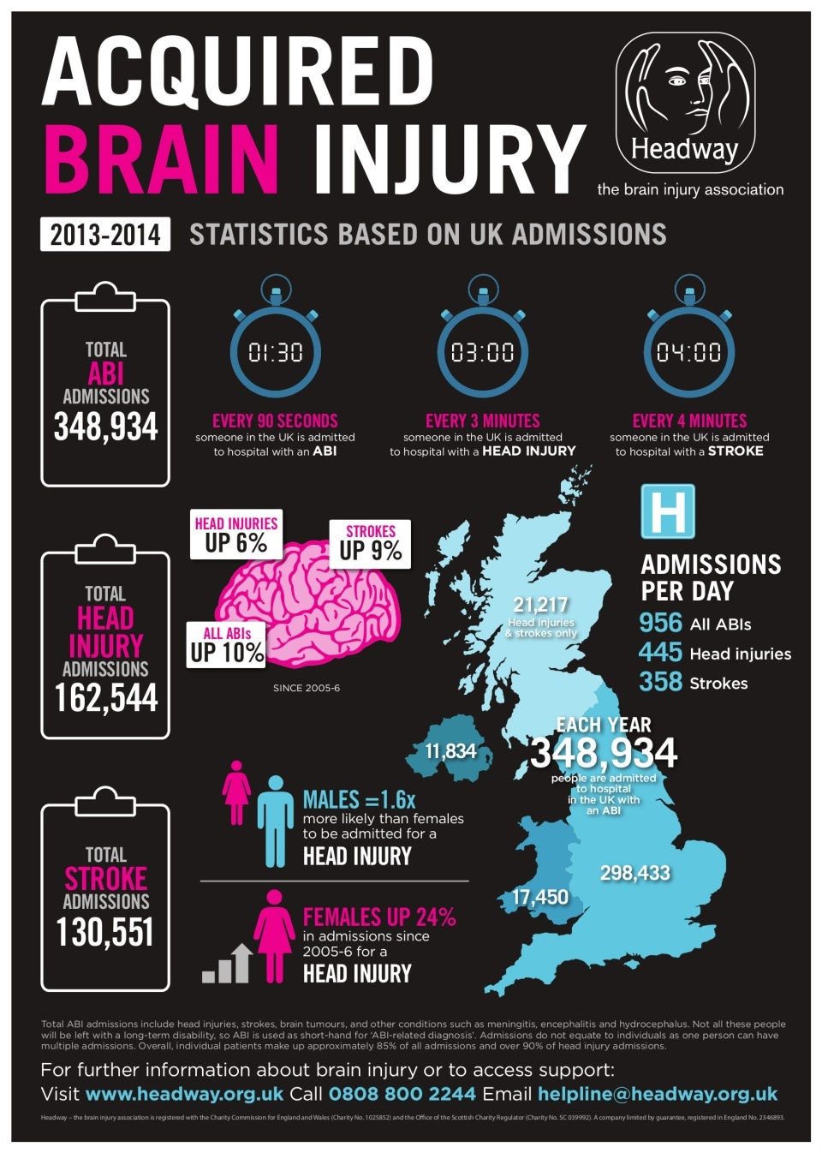Headway’s own [research](https://www.headway.org.uk/media/2883/acquired-brain-injury-the-numbers-behind-the-hidden-disability.pdf), published in 2015, has identified that the number of people admitted to the hospital in the UK with an acquired brain injury (ABI) related diagnosis has increased by 10% since 2005-06.

Admission to hospital for an ABI-related diagnosis does not necessarily mean a patient will be left with short or long-term deficits requiring rehabilitation or support.

Many of those admitted each year will be left with no lasting cognitive, physical, or behavioural deficits as a result of their injuries. Others will not be so lucky and will face an arduous battle to rebuild their lives and relearn lost skills most of us take for granted, including walking and talking.

However, even those who make good recoveries are still likely to require some short-term support and guidance.

Such a significant increase in the number of people admitted to hospital with ABI-related diagnoses, coupled with the fact the majority of these people will live a full life span, suggests an ever-increasing demand on support services. These include rehabilitation services provided by Headway across the UK to help people rebuild their lives and regain a degree of independence.

It is of great concern that at a time when more and more people in need of help, local authorities are reducing the financial support they are providing.

**Carer pressure**

The emotional, physical and financial pressure on carers is well documented. These pressures are particularly acute when it comes to brain injury.

Depression, anxiety and stress are serious problems among this vulnerable group of people. This is in part due to some of the effects of brain injury, which can be physical (including losing the ability to take responsibility for one’s personal care and hygiene needs), cognitive (including memory loss and an inability to process information), and emotional and behavioural changes.

This latter category of the effects of brain injury can be particularly impactful on carers. Anger, irritation and an inability to control one’s emotions can be common after brain injury. This can lead to brain injury carers having to cope with unintended verbal abuse or aggression.

Sadly, a study by Headway UK found that brain injury carers are failing to get adequate support from their local health care providers and social services departments.

The 2012 survey found that:

* 60% of brain injury carers feel they do not receive adequate support in their caring duties.
* Just 7% of brain injury carers receive help from social workers in their caring duties.
* Only a quarter (27%) of brain injury carers have received a carers assessment.
* Half (49.5%) of survey respondents were not aware they were entitled to a carer’s assessment, despite the legal requirement for local authorities to ensure carers are made aware of their right to an assessment.
* Just 24% of brain injury carers are satisfied with their health. Conversely, a worrying 8% are ‘very dissatisfied’ with their own health.
* 18% of brain injury carers rate their quality of life as ‘poor’ or ‘very poor’.
* 59% are showing signs of clinical depression with 21% in the severe or extremely severe range.

For many carers, their loved ones’ attendance at a Headway group – even if only for one day a week – provides much-needed respite from their caring duties.

**False economy**

Evidence strongly suggests that the funding available for adult social care is by and large insufficient to enable charities such as Headway, to best support people to live independent lives following brain injury.

The result of simultaneous cuts to local authority budgets and welfare benefits reform are having a detrimental effect on the physical and psychological wellbeing of brain injury survivors and their carers.

In addition to the human cost in the short term, the long-term implications could impact wider society as reduced access to vital services will lead to more people becoming reliant on more expensive long-term state support.

More specifically, Headway is in agreement with the Association of Adult Social Services (ADASS), which suggests that the new social care precept flexibility will not raise as much as the government suggests, and will not be enough to close the social care funding gap.

A recent survey by ADASS has highlighted that local authorities are preoccupied with cuts in funding, stating that they would have to cut services to cope with funding pressures.

This is reflected in commissioning practices that are increasingly seeing contracts being given to the cheapest provider – not the most appropriate to provide specialist services.

Rehabilitation from brain injury is a complex area and those affected require specialist support. Generic care provision from large providers catering for a range of conditions is unlikely to provide the same positive outcomes as can be provided by smaller charities specialising in bespoke, one-to-one brain injury support and rehabilitation.

It is a false economy to commission generic services on the basis of short-term cost savings. However, it is clear that many local authorities feel they have no other option.

**Conclusion**

Urgent action is needed to address the shortfall in financial support if local authorities are to continue to meet the growing needs of adults requiring social care and support.

A number of local Headway charity groups are under severe financial pressure at this time, with a number already reducing and or cutting services to clients and carers. This looks set to continue with many more likely to follow if funding from their local authority is not forthcoming.

For those people – including carers – who rely on the services of their local Headway groups, the impact could be devastating. It could also result in the local authority concerned having to deal with the additional financial implications of broken families, people requiring long-term residential care, increased levels of mental health issues and many people left socially disenfranchised and excluded from their own communities. These ‘hidden’ costs far exceed the level of funding required to run successful Headway groups at local level.