**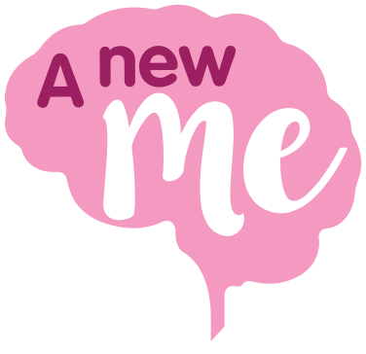\\nottm-svr\Communications\Headway logos\HW_CMYK_main_logo.EPS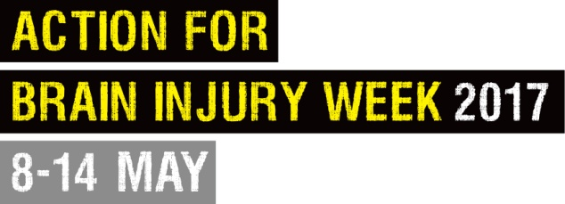**

***A New Me***

**About you and your creative piece**

We’re asking people with brain injury survivors to create a visual portrayal of how their ABI has changed them and created ‘a new me’. Whatever you create – be it a painting, poem, or short film – will be hugely personal to you.

The purpose of our campaign is to increase awareness of brain injury. To help us achieve this aim, we’re asking you to provide some context to your creation by providing some background information about how you brain injury has changed you, and the meaning behind your work.

The below form is to assist you with this, but please feel free to write as much or little as you feel comfortable with.

**Name**

|  |
| --- |
|  |

**Contact number and/or email address**

|  |
| --- |
|  |

**Please tell us about your brain injury.**

|  |
| --- |
|  |

**What message do you want to send to people through your creative work?**

(For example, provide inspiration to others? Raise awareness among the general public of the often hidden nature of brain injury? Inform people of how much change can result from brain injury?

|  |
| --- |
|  |

**How does your piece of art other creative piece relate to *A New Me* following brain injury? What does *A New Me* mean to you?**

|  |
| --- |
|  |

**Are you involved with a Headway group or branch? If so, please tell us which one and how they have helped/are helping you.**

|  |
| --- |
|  |

*Please tick this box to confirm you are happy for the information supplied to be displayed on the Headway website and/or social media platforms alongside your creative piece.*

Please return this information to us alongside your creative piece. If you are comfortable in doing so, please also provide a photo of yourself.

There are a number of ways to send your piece to us, depending on its type and, if it’s in an electronic format, the size of the files.

For all printed materials, post to:

Andrew Taylor  
Headway – the brain injury association  
Bradbury House  
190 Bagnall Road  
Old Basford  
Nottingham  
NG6 8SF

Please do not send us your original work as we cannot guarantee its safe return.

For all electronic materials such as photos, text documents and videos, please send as follows:

* File sizes under 20MB (e.g. one or two photos, Microsoft Word documents), please send by email to [website@headway.org.uk](mailto:website@headway.org.uk)
* File sizes over 20MB but under 2GB (e.g. multiple photos, short videos), please use a file sharing service such as [WeTransfer.com](https://wetransfer.com/)
* If using WeTransfer, first click to add your files, using ‘Add more files’ to include more. Don’t forget to add this form complete with your details. Next, enter [website@headway.org.uk](mailto:website@headway.org.uk) into the ‘email to’ field, then complete the process with your address and a short message before clicking ‘Transfer’.
* File sizes over 2GB (e.g. longer videos). Please contact Andrew on 0115 924 0800 or [website@headway.org.uk](mailto:website@headway.org.uk) to discuss the options.

----------------------------------------------------------------------------------------------------------------

Need advice? Contact James Coxon, Press and Campaigns Manager, on [press.manager@headway.org.uk](mailto:press.manager@headway.org.uk) or 0115 947 1901, or for website or social media queries, contact Andrew Taylor on [website@headway.org.uk](mailto:website@headway.org.uk) or 0115 947 1903.

[www.ANewMe.org.uk](http://www.ANewMe.org.uk)

#ANewMe