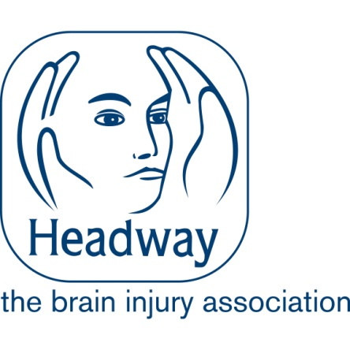

HEADWAY – THE BRAIN INJURY ASSOCIATION

JOB DESCRIPTION

Title Helpline Support Worker

Responsible to: Helpline Manager

Purpose: To respond in a caring, compassionate and professional manner to enquiries from brain injury survivors, families, carers, and professionals via telephone, email or letter.
Key Tasks:

- Provide an empathetic and accurate response to helpline enquiries received by telephone letter, email or letter.

- Continually develop knowledge and awareness of issues affecting survivors of brain injury and their carers.
- Ensure that complete and accurate enquiry records are maintained to satisfy funding requirements and the Data Protection Act.

- Maintain confidentiality at all times.
- Follow up enquiries and provide further information where necessary.

- Contribute to the upkeep of key research information on digital and paper databases.
- Undertake general administrative duties.
- Contribute to the development of resources produced by the Communications team.

- Represent Headway at internal and external events and conferences, as required.
- Undertake such other reasonable tasks as may, from to time, be deemed necessary.

