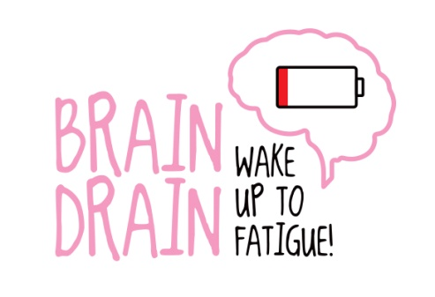

**Brain Drain videos**

Nobody understands the hidden effects of brain injury more than those directly affected. That’s why we’re putting brain injury survivors at the heart of our *Brain Drain* campaign.

We’re looking for brain injury survivors who are affected by fatigue to help us increase awareness of the impact it can have on everyday life by completing one of our *Brain Drain Diaries* using the templates provide – or by providing short snippets of video diaries.

**What is a video diary?**

Video diaries – also known as vlogs – are essentially very short snippets of someone talking to the camera about their life.

They are typically filmed as ‘selfies’ using the video feature on mobile phones, but of course you can ask someone to film you if it’s easier.

The idea is that you make regular short clips of you speaking to the camera. You can make brief recordings at key moments in the day, for example when you’ve just showered and perhaps are feeling at your most energetic, and then at times when your fatigue is really taking a hold in order to show the contrast between the two.

We’d like you to share those days – or key moments – where you cannot help with the house chores, those nights when you can’t sleep, when you’re unable to do basic tasks, or when you can’t be the parent or friend you want to be simply because of your fatigue.

But we also want you to show times when, with the right management, you’ve been able to achieve what you planned.

Ultimately, we’re looking for real-life, everyday examples to help people really understand how serious chronic fatigue is. With your help, we want people to *Wake up to fatigue!*

There's no need for a professional camera, just use any device you have. You could use your phone, or the one built into your laptop or desktop computer.

We will then share them on social media as part of our *Brain Drain: Wake up to Fatigue* campaign.

**Top tips**

* **Introduce yourself** (first name only is absolutely fine) and explain what’s happening, i.e. ‘It’s now 11.30am and I’m already struggling to do what I had planned for the day. I’m meant to be going shopping, but I can’t concentrate and I’ve got a banging headache. I need to sleep...’)
* **Keep each clip nice and short.** We suggest individual clips of moments during your day should be no longer that 30 seconds.
* **Talk straight to the camera about your personal experience.**
* **Hold your camera in portrait mode** (so your shot is taller than it is wide).
* Try to avoid filming anywhere that is **too dark or too noisy**. We cannot edit out background noise or brighten video clips for you.
* Don’t add **copyrighted material** (e.g. music or graphics) or any special effects.

**Stay safe**

We want as many people to take part but please follow the tips below.

* Remember **to not give your full name or personal details** – including where you live.
* **Don’t mention anyone else by name** without their full and explicit agreement.
* **Be cautious** if you are talking about your workplace/employer, or your school/teachers.
* Be sure to **show your footage to someone close to you** so that they can help you to ensure you’re not sharing too much.
* We strongly suggest you **send your footage to us**, rather than posting it on your own. That way, we can monitor responses.

**How do I send you the footage?**

We suggest you use a file-sharing website called WeTransfer. It’s simple to use – and free!

Firstly, you’ll need to ensure your video diary is saved on your phone or computer. Then go to [www.wetransfer.com](http://www.wetransfer.com) and click on the button that says ‘Take me to free’. Upload your file, add the email address for either James (press.manager@headway.org.uk) or Katie (press.officer@headway.org.uk) and click the ‘Transfer’ button.

You’ll receive an email telling you the file has been sent, and another notification to let you know we’ve downloaded it.

**Need help?**

If you would like any support or advice with how to go about completing a video diary or how to send it to us, simply call or email and we’d be happy to help.

* **James Coxon, Press and Campaigns Manager**

0115 947 1901; [press.manager@headway.org.uk](mailto:press.manager@headway.org.uk)

* **Katie Morris, Press Officer**

0115 947 1906; [press.officer@headway.org.uk](mailto:press.officer@headway.org.uk)