HEADWAY WARRINGTON COMMITTEE

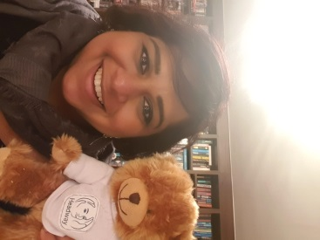***ASHWINI – CHAIR***

**Ashwini is the Committee Chair for Headway Warrington, having been involved on the committee since March 2016. Ashwini’s role includes liaising with Headway UK, conducting committee meetings, liaising with members and advising them of the group’s plans.**

**In her spare time Ashwini enjoys singing in a choir, swimming and attempting (and failing) to learn to play the saxophone.**

***JODIE* – *TREASURER***

**Jodie is Headway Warrington’s Treasurer. Her role includes managing the committees’ finances to ensure we have funds to keep our meetings going!**

**In her spare time she likes to play guitar and spending time with her dog, Trinny.**



***HARRIET – SECRETARY***

**Harriet is our newest member of the Headway Committee. Her role involves preparing the agenda for our committee meetings and taking the minutes at the meetings. Harriet also speaks with all the new enquiries to Headway Warrington.**

**In her spare time Harriet enjoys watching the rugby (although she is a St Helens fan!) and reading.**

***MIKE***

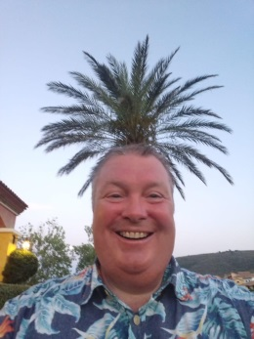

**Mike has been a member of the Headway committee since June 2016**

**Mike is a recently qualified OT and a keen gardener and cyclist!**

**His motto is “always attempt to do your best”!**

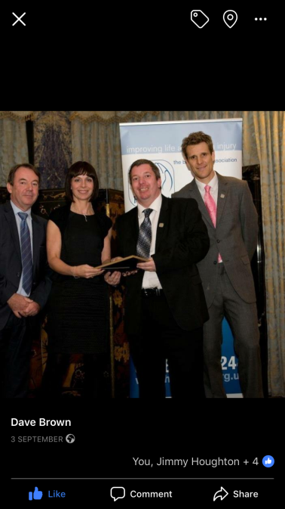

***DAVE***

**Dave has been a member of Headway Warrington since it was launched and has been on the committee for a long time!**

**Dave is a survivor of brain injury, but always tries to think positively!**

**Dave really enjoys attending the group sessions and is happy to provide support to any members that need it.**

**And finally Dave is a big rugby league fan and follows Warrington Wolves. He also enjoys watching musicals!**

***NIGEL***

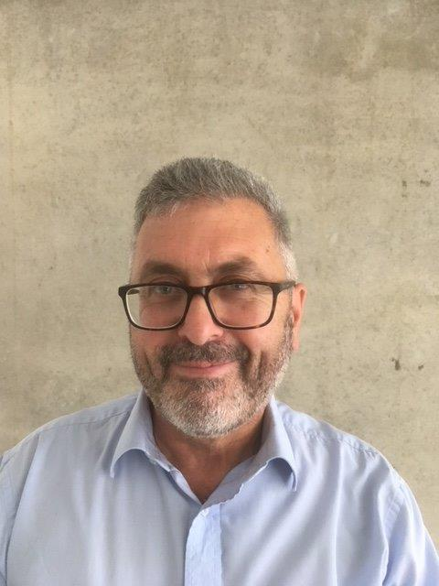

**Nigel has been involved with the Headway Charity for over 12 years and was formerly the Chair at Headway Halton – St Helens, and a Committee Member of Headway Warrington for 3 years. His hobbies include writing and researching military history, travel and photography. He supports ( or perhaps suffers ) Bolton Wanderers Football Club.**